• Launch Jenkins

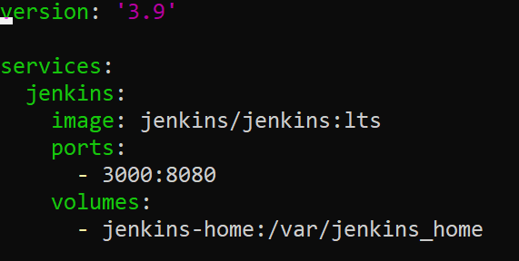

• Generate HTTPS creds to access git and import it to Jenkins secrets

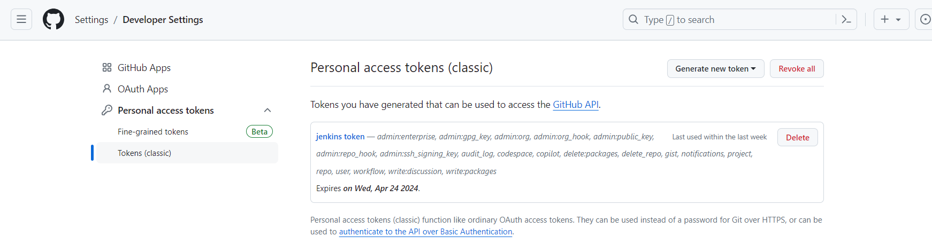

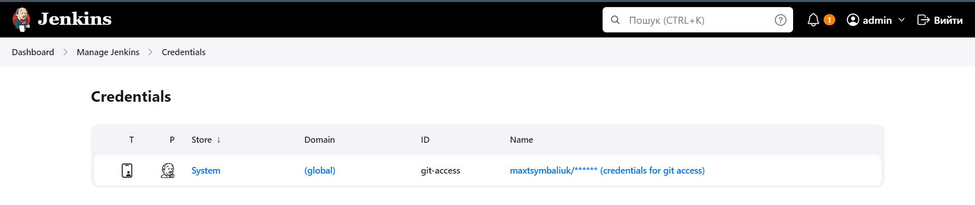

• Create Freestyle job which will use the imported secret and clone any remote repository

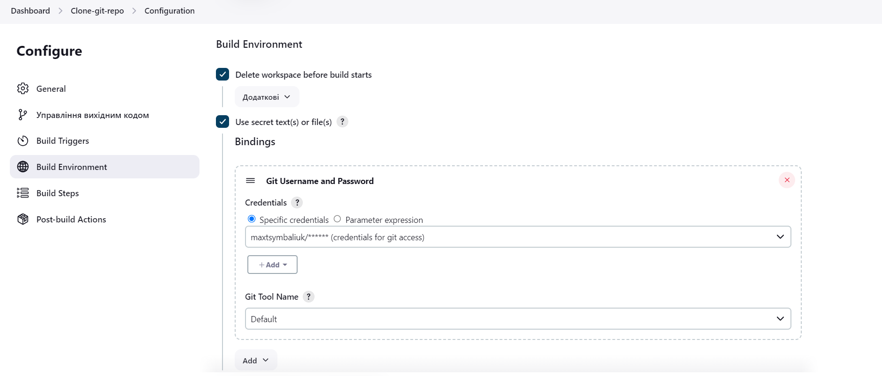

• Go to the repository folder where:

* create folder freestyle if it is missing
* create file with current data and time named freestyle/${BUILD_NUMBER}.txt
* add new file/folder to git
* commit change
* add a tag constructed as v0.1.${BUILD_NUMBER}
* push changes and tag to origin

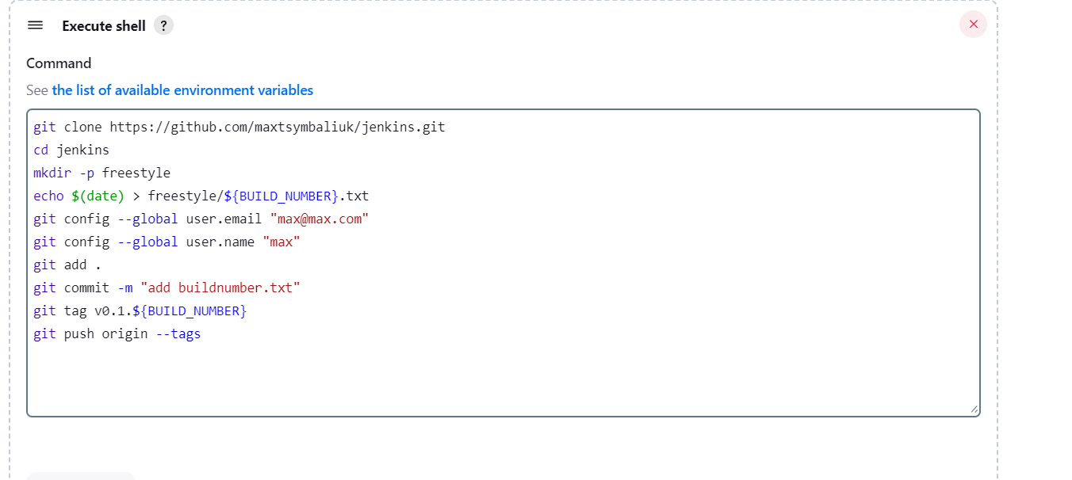

• Add the created file as artifact of the job

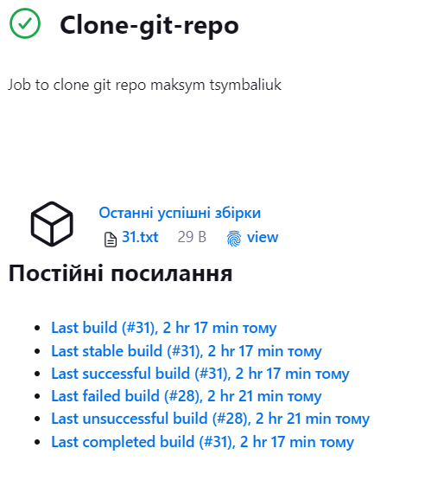

• Run the job several times and confirm that project has multiple files and tags after that

